Lesson 5. Introduction to Firebase and JSON

Aim: What is Firebase and how do we set it up?

Objectives: After the lesson, students should be able to:
- Obtain basic understanding of non-SQL DB Firebase

References:

CLASS PROCEDURE:
Do Now: In order to build games or apps using the NGram, we will need some tools to handle the corpus data records. It would be nice if we can have some tool that can store and sync data, and the data is synced acrosses all clients in real-time, and remains available when your app goes offline!

For this purpose, we will use Firebase! Check out this setup instruction.
https://firebase.google.com/docs/unity/setup

How do we set up Firebase for Unity?

Class Discussion / Presentation:
- What is Firebase?

- The Firebase Realtime Database is a cloud-hosted database.

- Firebase is nonSQL. Data is stored as JSON and synchronized in realtime to every connected client.

- When you build cross-platform apps with our iOS, Android, and JavaScript SDKs, all of your clients share one Realtime Database instance and automatically receive updates with the newest data.

- What is SQL and what is non-SQL?

- What is JSON?

- JSON (JavaScript Object Notation) is a lightweight data-interchange format. It is easy for humans to read and write. It is easy for machines to parse and generate. It is based on a subset of the JavaScript Programming Language, Standard ECMA-262 3rd Edition - December 1999.
- JSON is a text format that is completely language independent but uses conventions that are familiar to programmers of the C-family of languages, including C, C++, C#, Java, JavaScript, Perl, Python, and many others. These properties make JSON an ideal data-interchange language.
- What are the structures of JSON?
- JSON is built on two structures:
- A collection of name/value pairs. In various languages, this is realized as an object, record, struct, dictionary, hash table, keyed list, or associative array.

- An ordered list of values. In most languages, this is realized as an array, vector, list, or sequence.
- What are the different forms of data structures in JSON?
- These are universal data structures. Virtually all modern programming languages support them in one form or another. It makes sense that a data format that is interchangeable with programming languages also be based on these structures.
- In JSON, they take on these forms:
An object is an unordered set of name/value pairs. An object begins with { (left brace) and ends with } (right brace). Each name is followed by : (colon)and the name/value pairs are separated by , (comma).
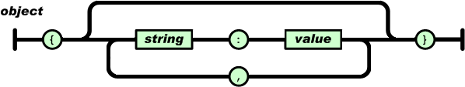
An array is an ordered collection of values. An array begins with [ (left bracket) and ends with ] (right bracket). Values are separated by , (comma).
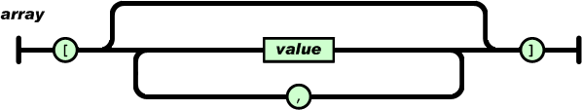
A value can be a string in double quotes, or a number, or true or false or null, or an object or an array. These structures can be nested.
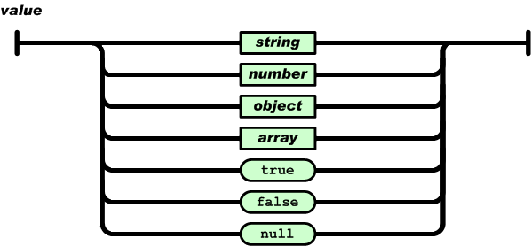
A string is a sequence of zero or more Unicode characters, wrapped in double quotes, using backslash escapes. A character is represented as a single character string. A string is very much like a C or Java string.
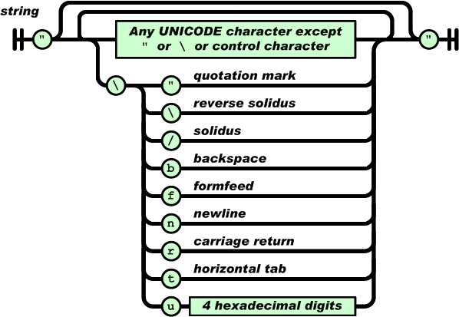
A number is very much like a C or Java number, except that the octal and hexadecimal formats are not used.
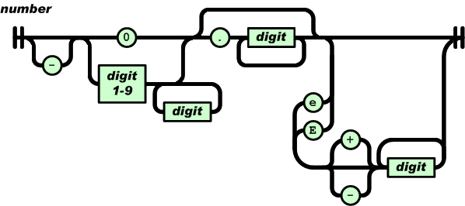

Whitespace can be inserted between any pair of tokens. Excepting a few encoding details, that completely describes the language.

Game Programming
Pair – sharing Activity #1:
Create a new Unity project and name it NGram, then go to the Asset Store, and search for
https://assetstore.unity.com/packages/tools/simple-firebase-unity-for-realtime-database-58337. This is s simplified version of Firebase + Unity package. If you think this one is easier to use then feel free to use this package.

App Development
Pair – sharing Activity #2:
With the most recent Android Studio, you can directly access Firebase in Android. Check out this online instruction https://developer.android.com/studio/write/firebase.html. Follow the instructions to set up a new Android project and connect to Firebase.

Pair – sharing Activity #2:
Before we build our project, we need to find out how to we parse the NGram corpus into JSON tree structure. Discuss with your partner and explore the solutions.

